LAB 9 – Documentation Generation

Course: AI Assisted Coding
Week 5
Name: Bala Sathwik Reddy
BATCH-14
2303A510B1

Task 1: Auto-Generating Function Documentation in a Shared
Codebase
Scenario
You have joined a development team where several utility functions are
already implemented, but the code lacks proper documentation. New
team members are struggling to understand how these functions should
be used.
Task Description
You are given a Python script containing multiple functions without any
docstrings.
Using an AI-assisted coding tool:
• Ask the AI to automatically generate Google-style function
docstrings for each function
• Each docstring should include:
o A brief description of the function
o Parameters with data types
o Return values
o At least one example usage (if applicable)
Experiment with different prompting styles (zero-shot or context-based)
to observe quality differences.
Expected Outcome
• A Python script with well-structured Google-style docstrings
• Docstrings that clearly explain function behavior and usage
• Improved readability and usability of the codebase

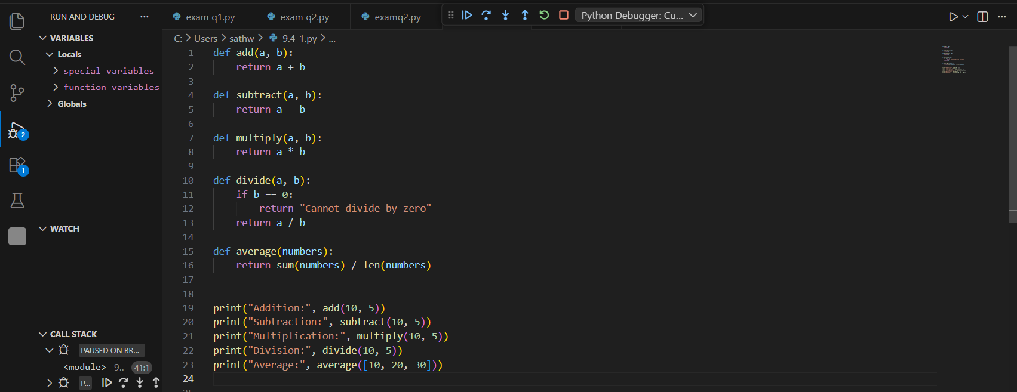

#OUTPUT:

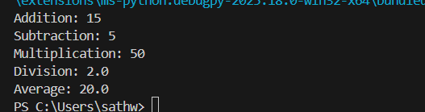

#prompt:
Generate Google-style docstrings for the following Python functions. Include: Short description Parameters with data types Return type Example usage.
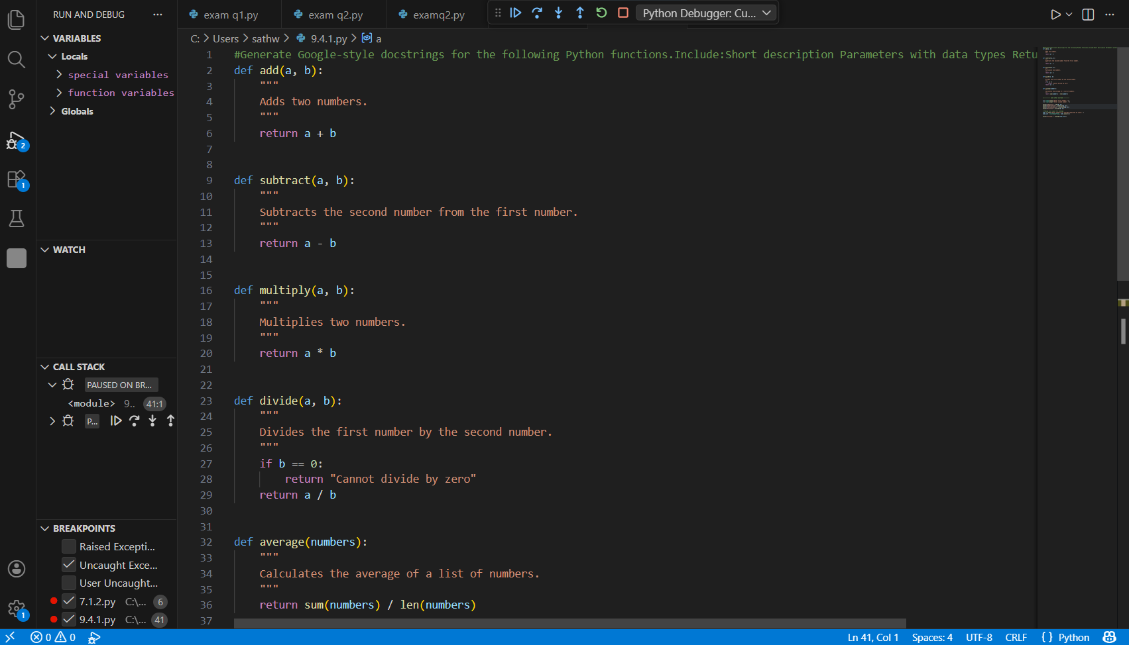
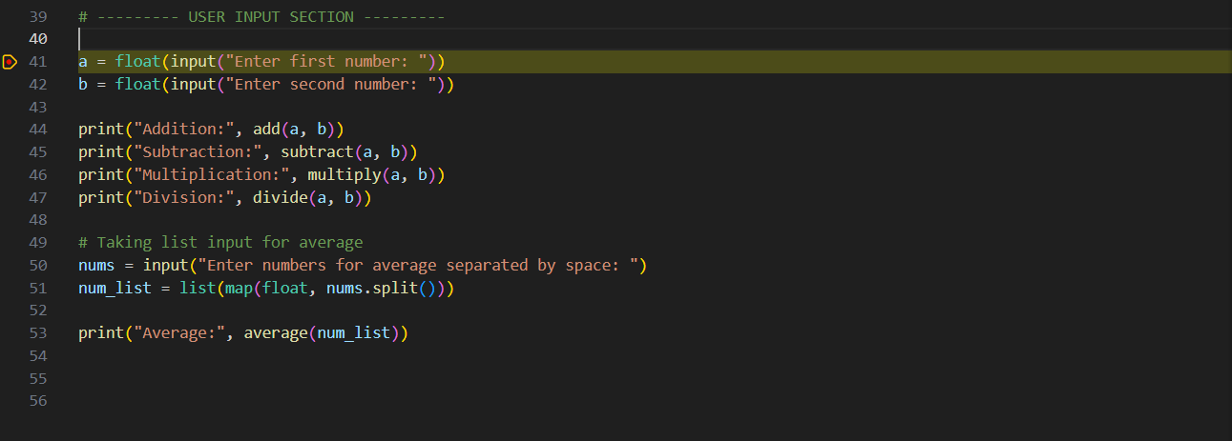

#Output
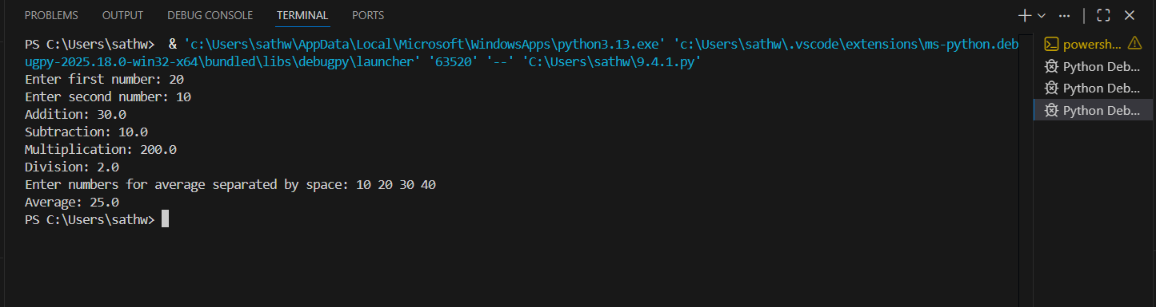
EXPLANATION:
In this task, we created mathematical functions like addition, subtraction, multiplication, division, and average.
Initially, the functions had no documentation.
We used an AI tool to automatically generate Google-style docstrings.
The docstrings include:
- Function description
- Parameters
- Return values
- Example usage
This improves code readability and makes the program easier for other developers to understand and maintain.

Task 2: Enhancing Readability Through AI-Generated Inline
Comments
Scenario
A Python program contains complex logic that works correctly but is
difficult to understand at first glance. Future maintainers may find it hard
to debug or extend this code.
Task Description
You are provided with a Python script containing:
• Loops
• Conditional logic
• Algorithms (such as Fibonacci sequence, sorting, or searching)
Use AI assistance to:
• Automatically insert inline comments only for complex or non-
obvious logic
• Avoid commenting on trivial or self-explanatory syntax
The goal is to improve clarity without cluttering the code.
Expected Outcome
• A Python script with concise, meaningful inline comments
• Comments that explain why the logic exists, not what Python
syntax does
• Noticeable improvement in code readability
Original Code (Without Comments)
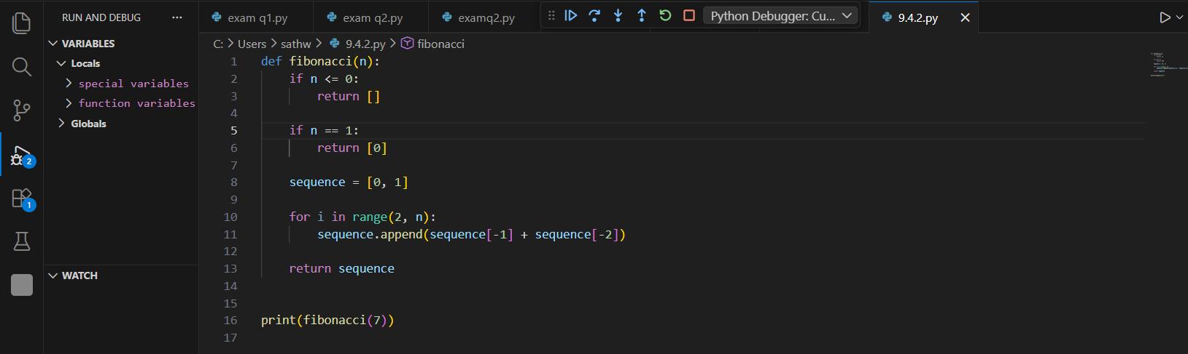
#OUTPUT:
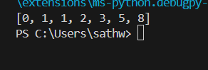
AI-Generated Inline Comments (Improved Version)

#prompt: Improve the readability of the following Fibonacci program by adding meaningful inline comments.Only comment complex or non-obvious logic. Do not explain basic Python syntax.

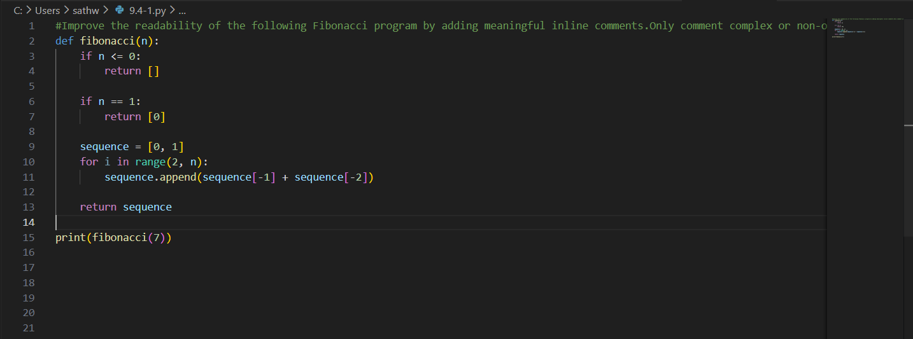
#OUTPUT:
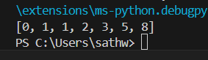
# EXPLANATION
In this task, AI was used to add meaningful inline comments to a Python program containing loops and an algorithm (Fibonacci).
Only complex logic was commented, and basic syntax was not explained.
This improved code readability and made the program easier to understand and maintain.

Task 3: Generating Module-Level Documentation for a Python
Package
Scenario
Your team is preparing a Python module to be shared internally (or
uploaded to a repository). Anyone opening the file should immediately
understand its purpose and structure.
Task Description
Provide a complete Python module to an AI tool and instruct it to
automatically generate a module-level docstring at the top of the file
that includes:
• The purpose of the module
• Required libraries or dependencies
• A brief description of key functions and classes
• A short example of how the module can be used
Focus on clarity and professional tone.
Expected Outcome
• A well-written multi-line module-level docstring
• Clear overview of what the module does and how to use it
• Documentation suitable for real-world projects or repositories
#CODE AND INPUT
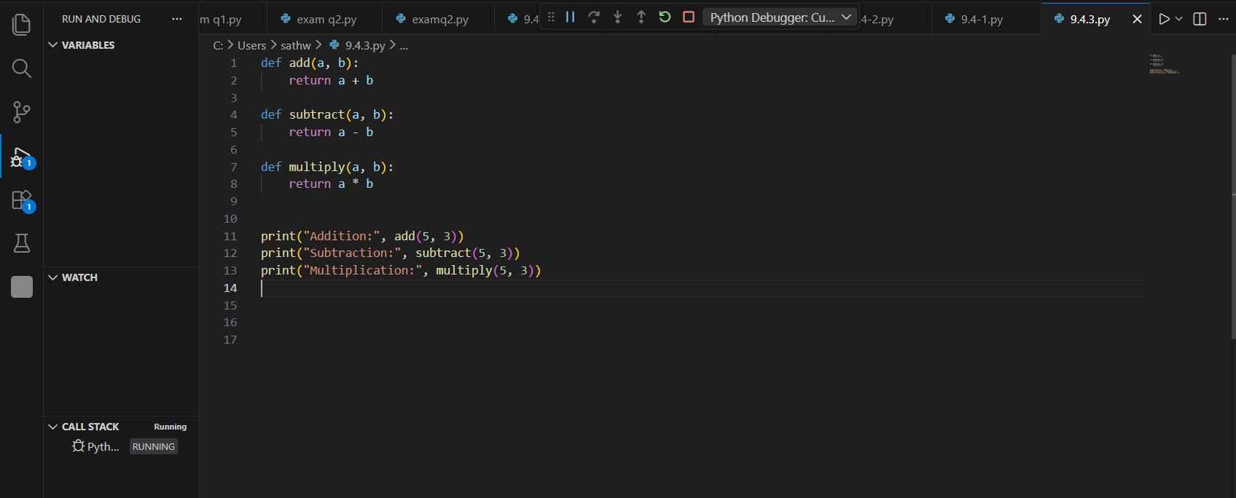
#OUTPUT:
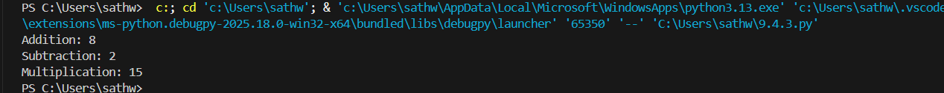

AI Generates Module-Level Docstring:
# Generate a professional module-level docstring for this Python file that explains the module purpose, dependencies, key functions, and includes a short example usage, without changing the existing code.
#CODE AND INPUT:
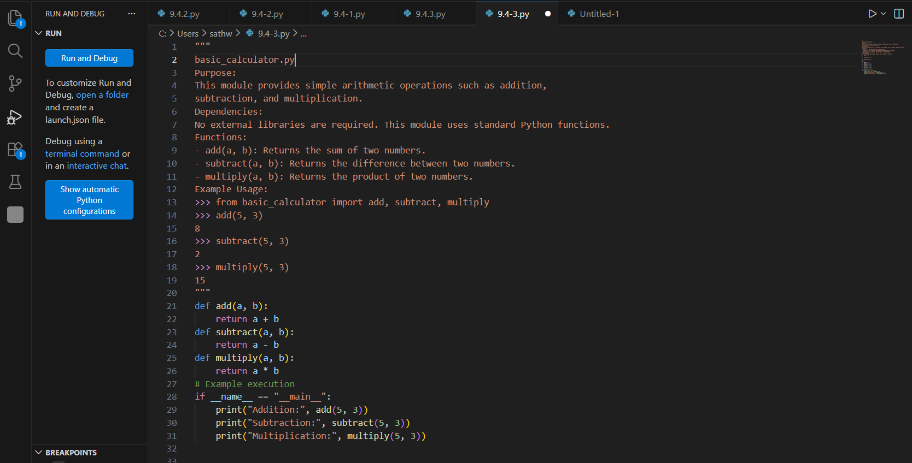
#OUTPUT:
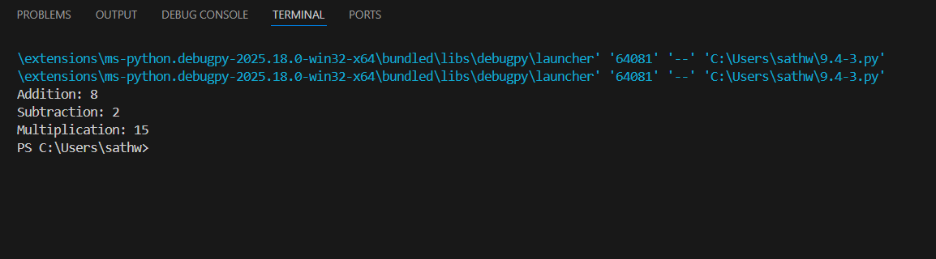
Task 3 is about adding proper documentation at the top of a Python file.
The goal is:
- To explain what the module does
- To mention required libraries (if any)
- To describe main functions
- To show how to use it
So when someone opens the file, they immediately understand its purpose without reading all the code.
👉 In short:
Task 3 improves professionalism and clarity by adding a clear module-level docstring.

Task 4: Converting Developer Comments into Structured Docstrings
Scenario
In a legacy project, developers have written long explanatory comments
inside functions instead of proper docstrings. The team now wants to
standardize documentation.
Task Description
You are given a Python script where functions contain detailed inline
comments explaining their logic.
Use AI to:
• Automatically convert these comments into structured Google-
style or NumPy-style docstrings
• Preserve the original meaning and intent of the comments
• Remove redundant inline comments after conversion
Expected Outcome
• Functions with clean, standardized docstrings
• Reduced clutter inside function bodies
• Improved consistency across the codebase
#CODE AND INPUT:
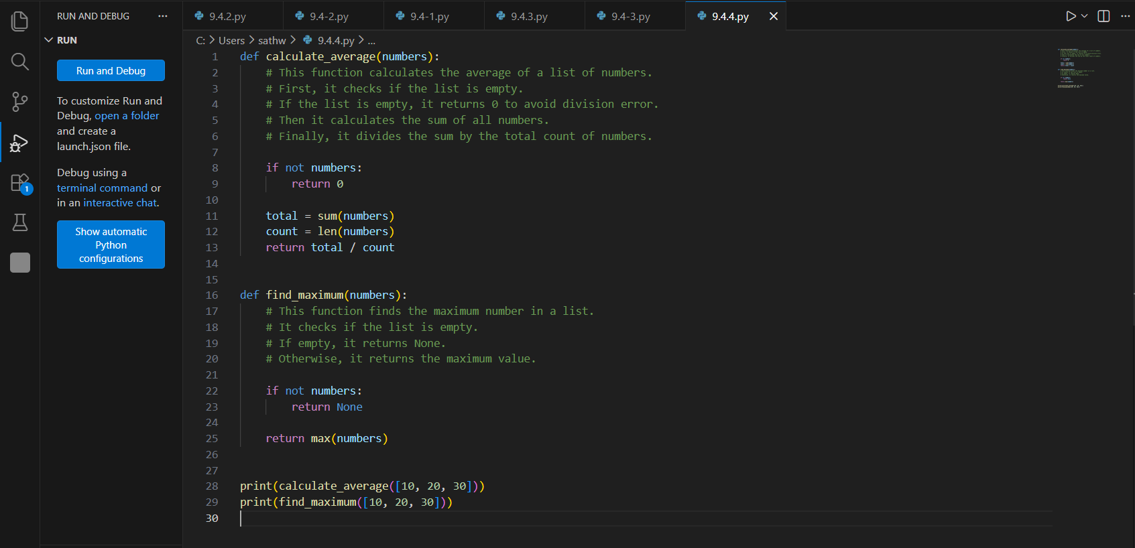

#OUTPUT:
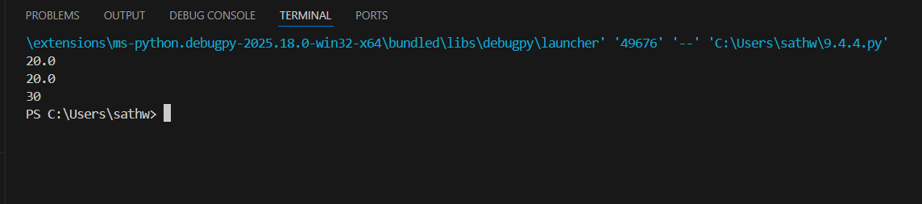

Converted Version:
#PROMPT:
Convert the inline comments in this Python code into structured Google-style docstrings for each function, preserve the original meaning, remove redundant comments inside the function body, and do not change the program logic.

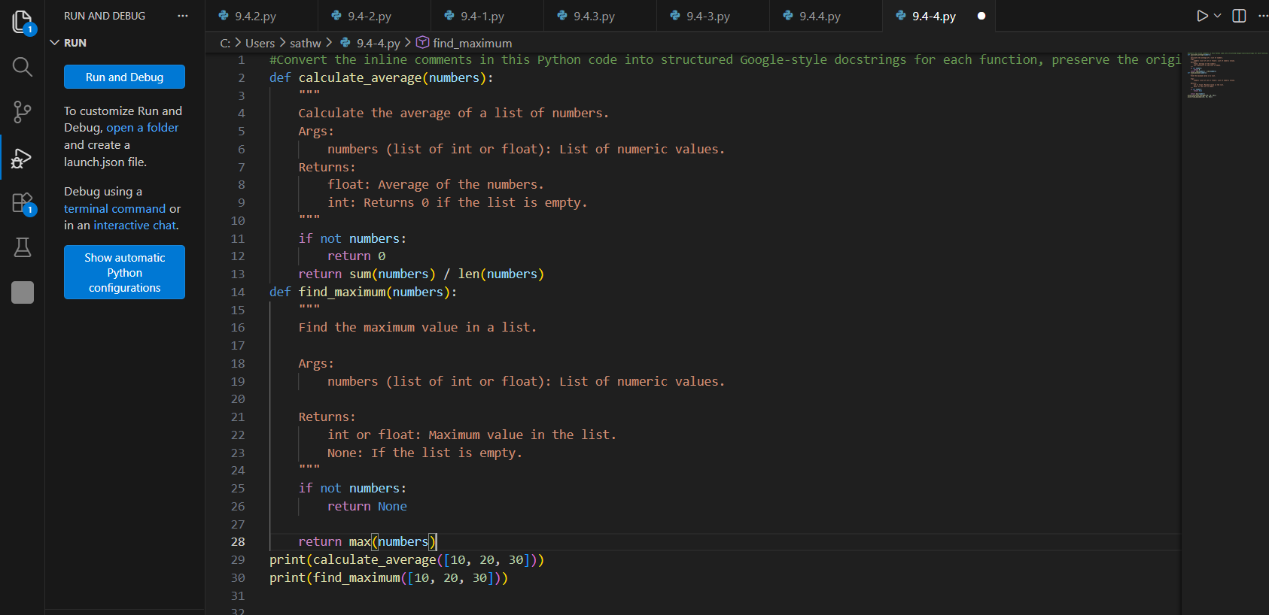
#OUTPUT:
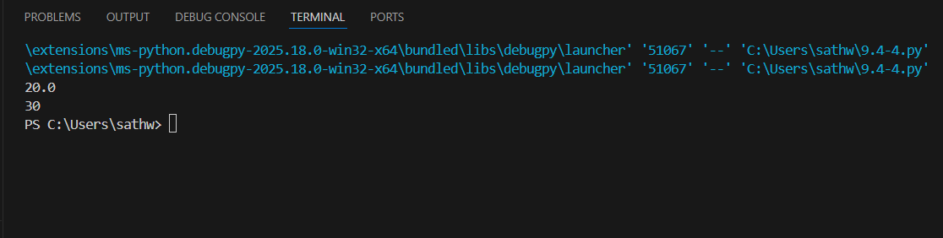

Task 5: Building a Mini Automatic Documentation Generator
Scenario
Your team wants a simple internal tool that helps developers start
documenting new Python files quickly, without writing documentation
from scratch.
Task Description
Design a small Python utility that:
• Reads a given .py file
• Automatically detects:
o Functions
o Classes
• Inserts placeholder Google-style docstrings for each detected
function or class
AI tools may be used to assist in generating or refining this utility.
#CODE AND INPUT:
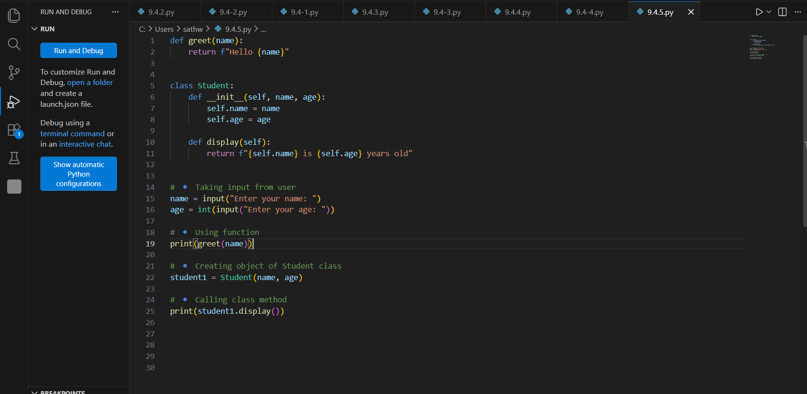
#OUTPUT:
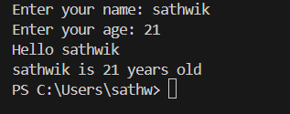
#PROMPT:
Generate a professional Google-style documentation for this Python program, improve code readability if needed, and ensure proper input validation and structured main() usage without changing the core functionality.
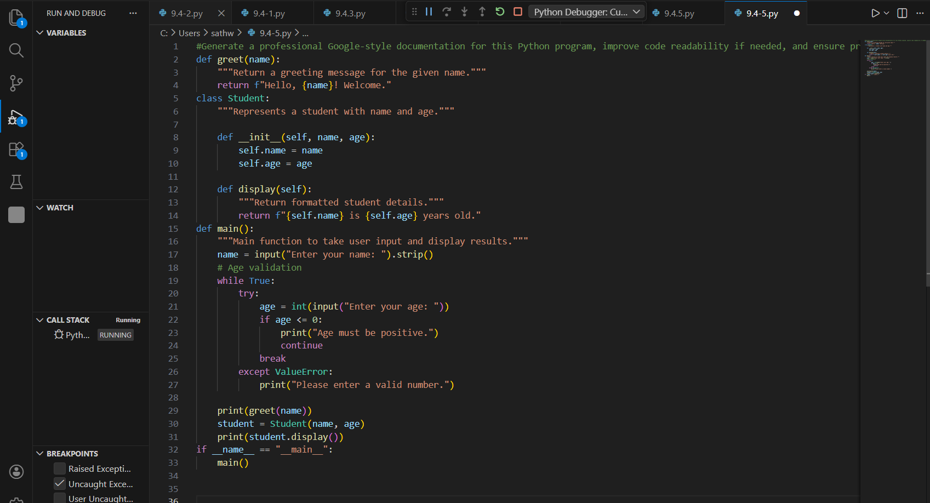
#OUTPUT:
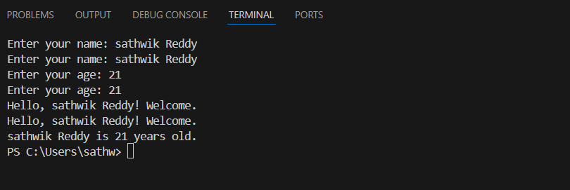

#EXPLANATION:
This program:
- Takes name and age from the user
- Validates age to ensure it is a positive number
- Uses a greet() function to display a welcome message
- Uses a Student class to store and display student details
- Uses a main() function to organize the program properly
👉 In short:
It is a well-structured, validated, and professional version of a simple greeting and student information program.

